Table of Contents
The Right Scope - Your Project Goal 2
What I want to demonstrate? 4
How will the basic architecture look like? 5
What Tech Stack I am looking at? 6
What I intend to do? 7
How my repo will look like? 8
How will I go about it? 9
What will I focus on? 11
How will my MVP1 look like? 12

The Right Scope - Your Project Goal
Build:
Real-Time Ad Personalization & Recommendation Platform
Inspired by:
- Zalando Ads
- Meta Ads
- TikTok recommendations
- Amazon sponsored products
But simplified enough for:
- single engineer
- AWS free tier
- 3 weeks

For a Principal ML Engineer position focused on:
- real-time recommendation systems
- ad personalization
- ranking/retrieval systems
- low-latency inference
- high-volume ML platforms
- cross-functional platform leadership
And based on your profile, you are unusually well-positioned to build a credible portfolio project here because your actual experience already overlaps heavily with:
- feature platforms
- retrieval/ranking systems
- observability
- MLOps
- event-driven architectures
- SageMaker deployment
- low-latency systems
- personalization/relevance optimization

What I want to demonstrate?
The project should showcase:
Area | Must Demonstrate
Problem framing | Why personalization matters
Architecture | Real-time ML system design
Retrieval | Candidate generation
Ranking | Personalized ranking
Streaming | User event ingestion
Feature engineering | Real-time + offline features
Serving | Low-latency inference
MLOps | CI/CD + monitoring
Trade-offs | latency vs accuracy
Observability | metrics and drift
Software Engineering | modular architecture
Documentation | principal-level clarity

How will the basic architecture look like?
User Events
(click/view/cart)
↓
Event Stream (Kinesis simulated)
↓
Feature Pipeline
↓
Feature Store
↓
Candidate Retrieval
↓
Ranking Service
↓
Top-N Ads
↓
Feedback Loop

What Tech Stack I am looking at?
AWS Free Tier Friendly
Component | Technology
Language | Python
API | FastAPI
Training | Scikit-learn / LightGBM
Embeddings | Sentence Transformers
Vector Search | FAISS
Streaming | Kinesis (or local Kafka if easier)
Storage | S3
Features | DynamoDB / Redis-like cache
Serving | FastAPI
Infra | Docker
CI/CD | GitHub Actions
Monitoring | CloudWatch
Experiment Tracking | MLflow local
IaC | Terraform (minimal)

What I intend to do?
- Business Problem Definition
- System Requirements
- Architecture Design
- HLD + LLD
- Component Design
- Dataset Strategy
- Retrieval Design
- Ranking Design
- Feature Store Design
- API Design
- AWS Deployment
- GitHub Repo Structure
- Agile Epics & Stories
- Kanban Breakdown
- CI/CD
- Observability
- README
- Architecture Diagrams

How my repo will look like?

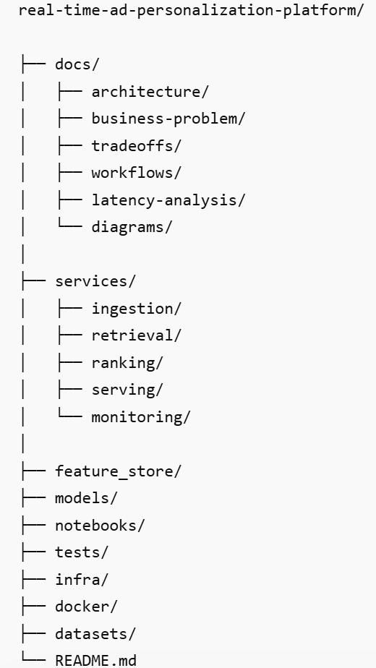

How will I go about it?
3-Week Execution Plan
WEEK 1 — Foundation & Architecture
Deliverables
Problem Definition
- business goals
- KPIs
- constraints
- assumptions
Architecture
- system design diagrams
- component workflows
- sequence diagrams
Repo Setup
- modular structure
- Docker
- GitHub Actions
- linting
- testing
Dataset
Use:
- H&M fashion dataset
- RetailRocket
- synthetic ad events
WEEK 2 — ML + Serving
Build:
- feature engineering pipeline
- candidate retrieval
- ranking model
- FastAPI inference service
- feature store simulation
Add:
- latency measurement
- caching
- ranking logic

WEEK 3 — Productionization
Add:
- monitoring
- drift checks
- A/B experimentation simulation
- dashboards
- documentation
- architecture trade-offs
- README
- screenshots
- demo video

What will I focus on?
What Makes This Stand Out
Your project should heavily emphasize:
1. Latency Budgets
Example:
Stage | Latency
Retrieval | <30ms
Ranking | <40ms
Total API | <100ms
This is VERY relevant to Zalando’s JD.
2. Trade-Off Documentation
Example:
Choice | Why
FAISS over brute force | latency
Batch features + online features | freshness
LightGBM over deep ranking | inference speed
Async ingestion | scalability
Principal interviews LOVE this.
3. Production Reliability
Add:
- retries
- fallback ranking
- cache
- graceful degradation
Even mocked versions are excellent.

How will my MVP1 look like?
Ideal Recommendation Pipeline
Stage 1 — Candidate Retrieval
Retrieve:
- 100 candidate ads
Using:
- content similarity
- category affinity
- popularity
- collaborative filtering-lite
Stage 2 — Ranking
Rank top ads using:
- CTR prediction
- recency
- personalization score
- session similarity
Stage 3 — Re-ranking
Business rules:
- diversity
- sponsored boost
- category balancing
This is very realistic for ad-tech.

Critical Design Choice
DO NOT Build Deep Learning Heavy System
Avoid:
- transformers for ranking
- GPU pipelines
- RL recommender systems
- distributed training
Instead:
- focus on architecture
- retrieval/ranking pipeline
- online serving
- feature freshness
- latency optimization
That aligns far better with Principal MLE interviews.

